

[NCC Global Assignment]
Candidate Name: | Khin Zaw Oo
Candidate ID Number: | 206150
Center Name: | KBT001 - KBTC College (School of IT)
Unit: | MAD
Qualification: | ( L5DC)
Date: | 7/25/2025
Total Word Counts: | 2399

Table of Contents
Task 1 Scope and Position of Mobile Apps 2
1.1 A). Key Characteristics of Mobile Apps 2
1.2 B). Scope and Limitations 2
1.3 C). Developing for Multiple Platforms 3
2 Task2 Development Architectures, Platforms, Languages and Tools 4
2.1 (a): Key Characteristics of Native Apps 4
2.2 (b): Key Characteristics of Cross-Platform Development Frameworks 4
2.3 (c): Current Trends in Development Tools 5
2.4 (d): Native vs. Cross-Platform Approaches 5
3 Task 3 Planning and Designing the Mobile Application 7
3.1 (a): SDLC and Mobile Apps 7
3.2 (b): Specification and Design 8
4 Task 4 10
5 Task 5 23
5.1 (a): Object Orientation in Kotlin and Android 23
5.2 (b): Inheritance Usage in Fitness Tracking App 23
References 25

Task 1 Scope and Position of Mobile Apps

A). Key Characteristics of Mobile Apps
Applications for mobiles, especially tracking applications for physical exercise, are mobile, interactive, and user-centered. Offline functionality, e.g., tracking a run or a cycle in the absence of the network, is a must. Local data storage is performed with the help of libraries such as SessionManager or SharedPrefManager, then synchronization with the server with the help of classes, for instance, SaveRunningRequest.
Push notifications--even though not yet implemented--can be added for more interaction, such as prompting the user to enter workouts or for achievements. The touch-based app interface also maintains simplicity in navigation by way of layout files (e.g., activity_sign_up.xml, fragment_profile.xml) and architecturally modular objects like ActivityListFragment.
Real-time syncing and backend integration are also very much important, utilizing Retrofit APIs (RetrofitClient, Api.kt) for user data handling. Security is also handled with user login, session management during login, registration, and logout.
Lastly, design with activities and fragments in a modular application manner (e.g., MainActivity, YogaActivity, fragment_graph.xml) provides for design scalability, precisely in accordance with varying screen sizes, with clear visual depictions for application advancement through pieces like Graph.kt (Anon., 2024).

B). Scope and Limitations
The scope of fitness tracking apps is large and allows such features as activity recording, goal setting, real-time tracking, and progress visualization. The app also enables a user to monitor various activities (running, biking, swimming, yoga), gathering such measurements as distance, time, and pace in different activity formats. They are examined with the use of such tools such as fragment_graph.xml and Graph.kt so that the users could enhance their performance.The suitability of the device is, however, a major constraint since there is a very broad range of Androids devices. They supported consistency because XML layouts and constraint-based designs can work, but it is still difficult to fully responsive UI at a number of different screen sizes.Performance is also limited by hardware. Entry-level devices might have faulty sensors (e.g. GPS, accelerometer) and thus data on their activity can be inaccurate. These sensors as well use the battery power hence optimization is necessary mostly when the sessions last long.Inaccuracies in sensors should be also addressed by the app. In case GPS or step counters do not work, the information may prove misleading, and this will adversely impact the motivation of the users. One of the possible solutions is the provision of a manual data entry or calibration capabilities.In a few words, although fitness apps can give good health information, the developers need to improve their applications regarding concerns such as device fragmentation, sensor accuracy, and battery consumption to deliver quality interaction.

C). Developing for Multiple Platforms
Development of Android and iOS mobile applications brings in a number of challenges. Every platform has its languages (Kotlin/Java on Android, Swift on iOS), IDEs (Android Studio, Xcode) and its own UI guidelines. This usually necessitates having two codebases and this makes it both expensive and time consuming to develop. It is also very difficult to maintain UI/UX consistency since Android employs material design and iOS Human Interface guidelines. It is up to developers to balance between the coherent brand image and native interface such as gestures and navigation. The API access and hardware access are also different. Such features as background GPS tracking and alerts vary across platforms, with iOS platforms commonly having more data privacy limits and behind-the-scenes execution restraints as compared to Android. Cross-platform frameworks are applied to smooth out development as well: Flutter, React Native, or Xamarin. These enable developers to author a single codebase that supports both platforms and yet provide tooling to address platforms specific capabilities. Nevertheless, platform-level customization presumably needs to take place to realize full optimization. Otherwise, Progressive Web Apps (PWAs) are platform-independent and easy to maintain, with fewer available hardware capabilities, which does not suit the activity of fitness tracking. Finally, The multi-platform development has to match code efficiency, performance, and native experience. Most of these challenges can be overcome by utilizing cross-platform frameworks and modular design (Anon., 2025).
[Word Count : 657 ]

Task2 Development Architectures, Platforms, Languages and Tools

(a): Key Characteristics of Native Apps
Native apps are programmed for one platform only, either Android or iOS, with platform-sensitive programming languages, for instance, Kotlin/Java for Androids and Swift/Objective-C for iPhones. Native development's biggest benefit is performance and responsiveness, also very much wanted for fitness tracking apps based on current data in real time, for instance, the GPS position, speed, pace, when performing exercise like run or bike ride.

Another benefit are access to full hardware and API devices, allowing it to be simple to integrate with features such as GPS, step tracking, accelerometers, and health features such as Google Fit and Apple HealthKit. Native applications are able to perform background services efficiently, a key requirement for ongoing tracking irrespective of the application being in the background.

But one major drawback of natively developed apps is the need for separate codebases for Android and iOS. It results in increased time taken for development as well as a higher cost, owing to the need for independent implementation and maintenance for functionalities like tracking workouts or logging in. It may also prove challenging for consistency between the two platforms, given differences in design guidelines and release cycles.

Briefly, natively-written apps promise optimal performance and hardware interaction--ideal for fitness tracking or anything else--but at a higher cost in terms of labor and overhead with dual-platforming (Anon., 2025).

(b): Key Characteristics of Cross-Platform Development Frameworks
Cross-platform development means developing apps with a shared codebase for Android as well as iOS with much lower time, cost, and complexity. Cross-platform development uses technologies like React Native and Xamarin.

Evolved from Facebook, React Native is JavaScript-based and offers a good set of UI components. While the performance is one notch below native apps, it is good enough for fitness tracking functionality. It also offers support for native module interaction for device features such as GPS, sensor, and notification. For example, live tracking can be done with packages such as react-native-geolocation-service, push notification can with Firebase. It can, however, become cumbersome when dealing with highly platform-centric functionality, where in most scenarios a native bridge code in Java/Swift is inevitable.
React Native is well suited for quick development and flexibility in UI, whereas Xamarin is well suited for hardware-based apps with close to native performance needs. Both are good with some compromise in performance and platform-based level integration.

(c): Current Trends in Development Tools
New mobile app development is being shapedby means of abundant utilities,promotionof productive power, joint work, and quality of the code.

Android Studio (on IntelliJIDEA) and Xcode are the best-rated IDEs on native applications. Android studio offersintelligent code completion, interface design preview, andJetpacklibrary features as Android Studio; however, Xcode available interface builders, among the iOS simulators, supports Swift applications.

The workshops of the cross-platform developers are fondof using Visual Studio (they built Xamarin) and Visual Studio Code (used by the others such Flutter and React Native) because it allows cross-plugin compatibility andextreme re-configurability.

With version control the standard applies to code change management and team working, namely, Git.Hosts GitHub, GitLab,and Bitbucket offer pull request, issue tracking, integration with CI/CD pipeline,triggering test runs automation, andso on.

It is also a requirement to have automation testing utilities. Unit testing It is typical to use JUnit, Espresso, etc. to test native apps.Such tools as utilities, Appium, the test tool of Flutter, etc., Detox are applied to cross-platform apps because of the ability to use Android, and, iOS aswell.

In a word, new development tooling, starting withIDEs, going through version control, contending with test frameworks, is equalizing development, improving code, and speeding up, securing deploys.

(d): Native vs. Cross-Platform Approaches
Native apps are more high-frequency, particularly when it comes to demanding activities such as real-time sensor tracking or more accurate GPS mapping, not to mention background data processing activities which must be user-friendly. Native tools also give the best accessibility to system level APIs such as Google Fit and Apple HealthKit. This means easier UI, improved accuracy, and consistency in training, assessing it to users.
But of course the drawback is that this requires two codebases and has the result of longer development time and greater cost and possible lack of consistency with platforms. Such a feature as editing workout targets has to be written and tested in Android and iOS separately.
However, cross-platform development allows having united code base, which is quicker and economically feasible to release an application on multiple platforms. This would be optimal in the case of MVPs or startups that require a fast iteration. It is easier to maintain as bug fixes and updates are implemented on both the platforms at once. Key elements such as fitness session rules and graphs as the progression framework can be reused and would be more efficient.
Yet, cross-platform applications can be a little slower, especially in scenario of complex sensor integration or background services. Although, the integration with certain platform-specific features may need some native bridge code again introducing complexity to the project.
There is also popular hybrid strategy: a mix of cross-platform (the quickest deployment) and native (better-performing as the application grows), where a cross-platform model is used at the beginning of the development and later migrated to the native one.
[Word Count : 863 ]

Task 3 Planning and Designing the Mobile Application

(a): SDLC and Mobile Apps
The Software Development Life Cycle (SDLC) is a structured framework that guides the development of software applications, ensuring the final product is functional, efficient, and user-centric. For mobile apps like the Fitness Tracking App, the SDLC plays a vital role in creating a high-quality experience that aligns with user needs and expectations.
The first stage, requirements analysis, involves gathering user needs and defining core functionalities. For a fitness app, this includes activity tracking (e.g., running, swimming), monitoring distance and pace, setting fitness goals, and accessing performance statistics. The team collaborates with stakeholders to identify target platforms (Android, iOS), key features, and technical constraints such as sensor usage and offline functionality.
The second stage is design, where the app’s structure and interface are planned. Wireframes and mockups are created, and UI patterns are selected for intuitive navigation. Fragments and layouts like activity_main.xml or fragment_graph.xml define how users interact with different modules. System architecture decisions are also made here, including backend APIs, database schema, and UI responsiveness across device sizes.
In the implementation step, the actual code in the choice toolset and programming languages is initiated in the actual platform: Kotlin for Android, Swift for iOS, or React Native in cross-development. These modules typically group for RunningActivity, SaveRunningRequest, and processing for the user session are resolved. These modules typically group for RunningActivity, SaveRunningRequest, and processing for the user session to get decided. Among the software tools for making teamwork and version control feasible, there is a tool called Git.
The test phase is applicable such that the execution of an application behaves as desired. It contains functional (action tracking, targets) and performance GPS accuracy testing and UI testing (flexible layouts). Utilities integrated are defect detection automation and fixing bugs, for example. JUnit, Espresso, or Firebase Test Lab. It can also be initiated in the form of realistic users during a process like beta testing.
And, finally, there is a deployment process, which is transferring the app to the app stores like Google Play or the Apple App Store. Also, developers also will come up with release versions and application descriptions in addition to the application of platform-specific specifications. After deploying the application, it shall be in maintenance where there are patching, updates, and compatibility that are carried out intermittently (Anon., 2025).

(b): Specification and Design
The design and specifications for the Fitness Tracking App are laid down considering providing a feature-rich, engaging, and easy-to-use mobile experience. It accommodates varying physical activities, e.g., cycling, running, swimming, weightlifting, and yoga, with a functionality for goal setup, tracking, and viewing historical activity.
User input also encompasses the personal data (age, name, weight, height) as well as exercise data (speed, distance, time, calories expended, GPS data). Sensor data from the unit are also taken in real-time with the program for tracking, acquisition, and storage being justified only for analysis.
The system is designed with a client-server architecture. The mobile application (client) holds the user interface and also holds local tracking, while for the users, permanent storage and synchronization are taken care of, and REST APIs are responsible. Module descriptions are as follows:
- User authentication (login, registration),
- Activity tracking (live session recording),
- Progress visualization (charts, stats), and
- Offline syncing, which allows data entry without an internet connection.
The user interface emphasizes simplicity, consistency, and convenient accessibility. It adheres to Material Design principles, including a minimalist layout design with touch functionality. It features a bottom navigation bar connecting main components: Home, Track, Progress, and Profile.
- The Home screen provides a personalized greeting and quick-start options.
- The Track screen displays real-time stats and session controls.
- The Progress screen shows charts of past performance.
- The Profile screen allows users to update personal details and track milestones.
Device-responsive design with scalable layouts. Design for usability with large type, high contrast in color, and feedback mechanisms (e.g., with toast messages or vibrotactile feedback) when an action has been taken.
[Word Count : 648 ]

Task 4
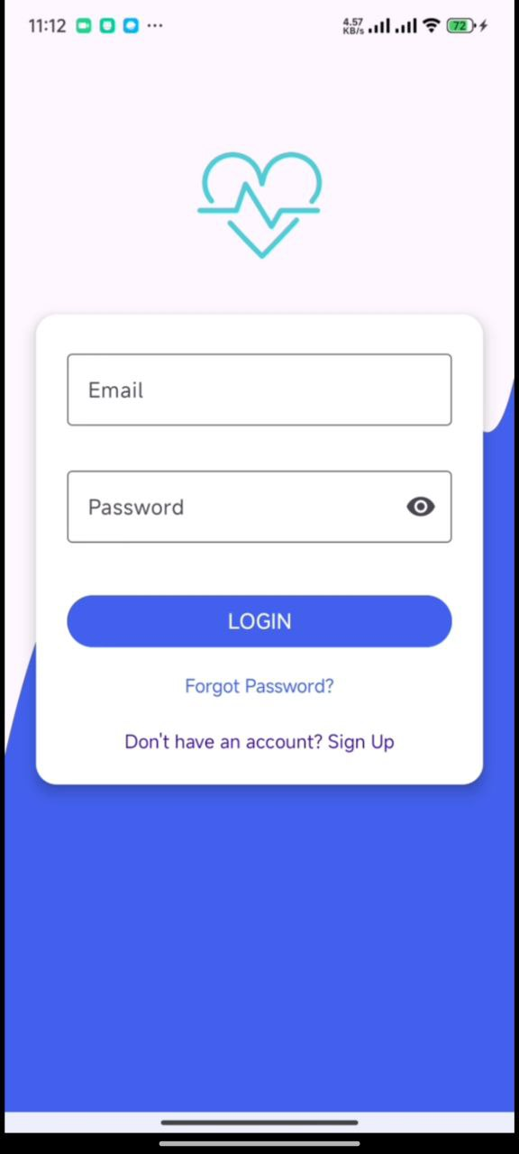
Figure 1login
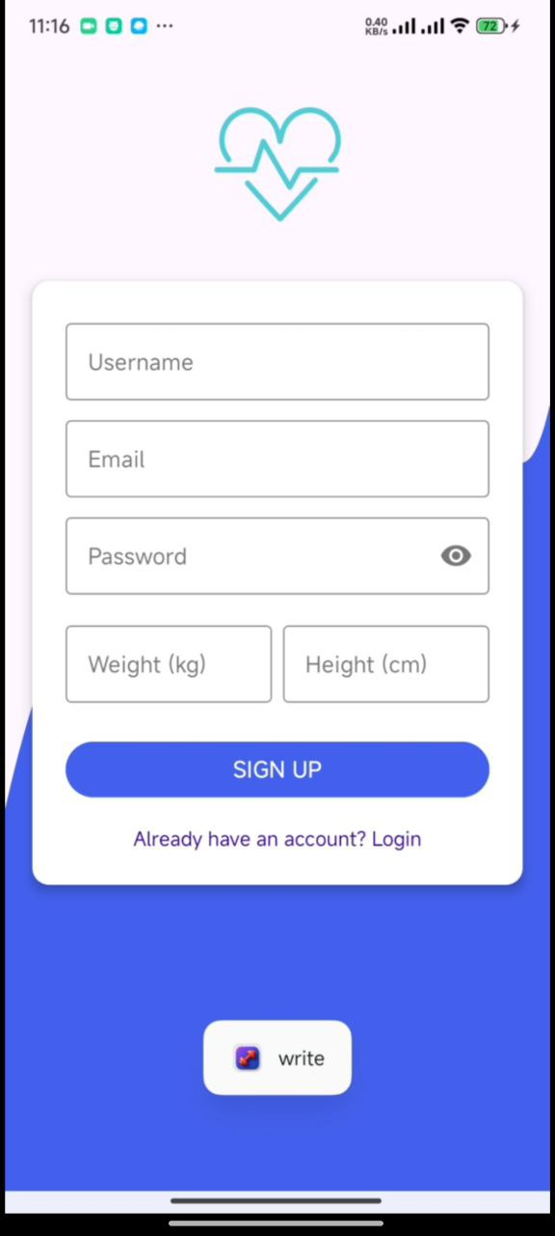
Figure 2Sign up

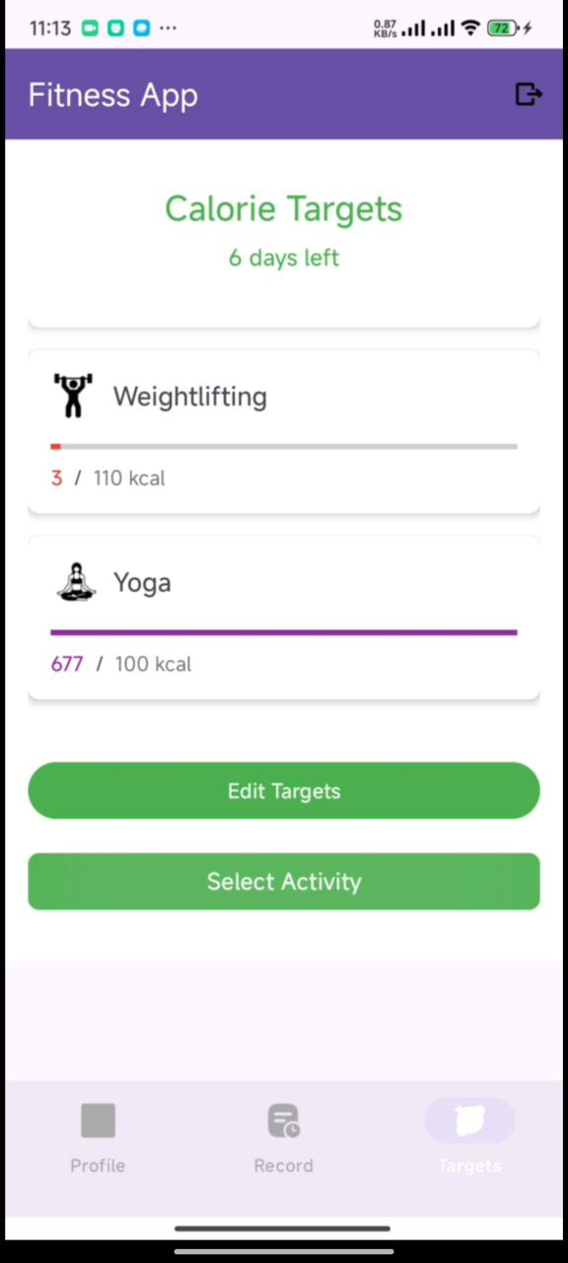

Figure 3Calorie Targets

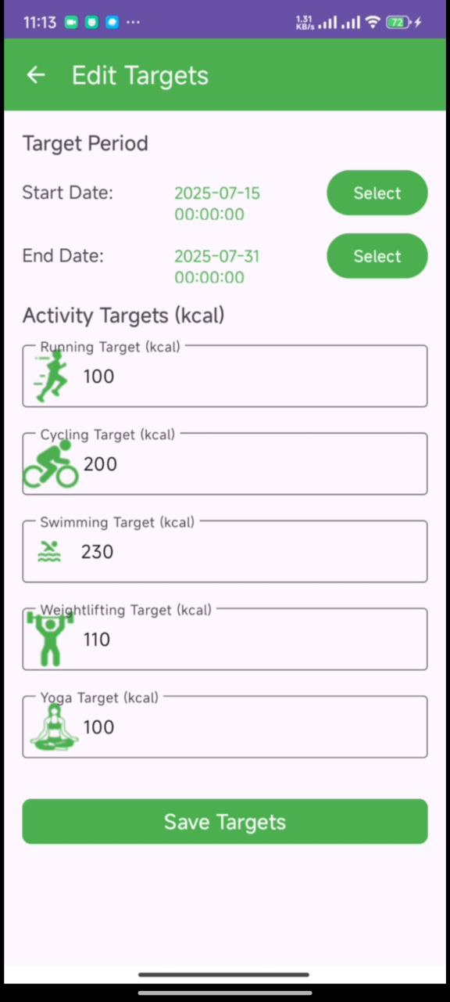
Figure 4Edit Target

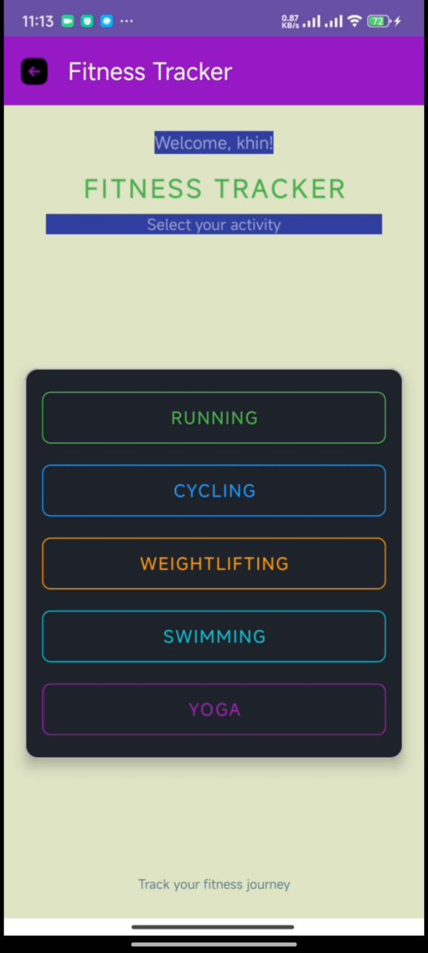
Figure 5Select your activity

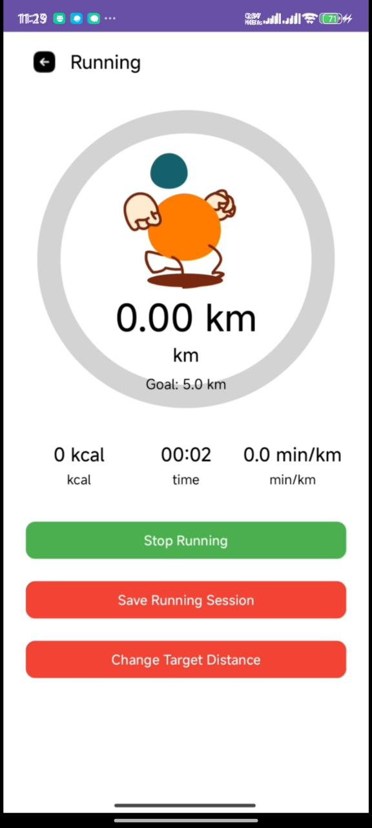
Figure 6Running Activity

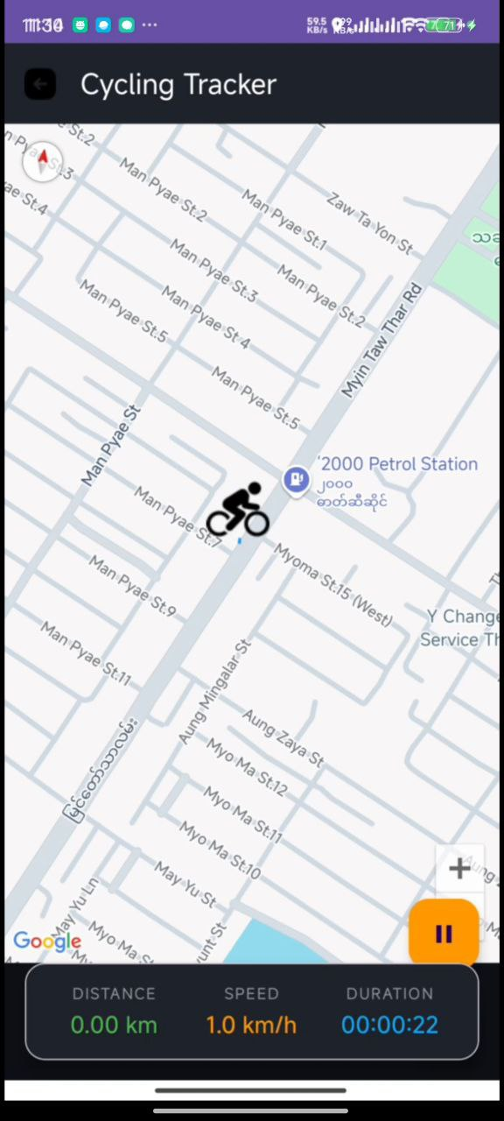
Figure 7Cycling Tracker

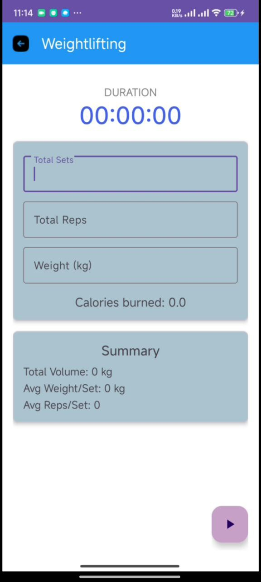
Figure 8Weightlifting Activity

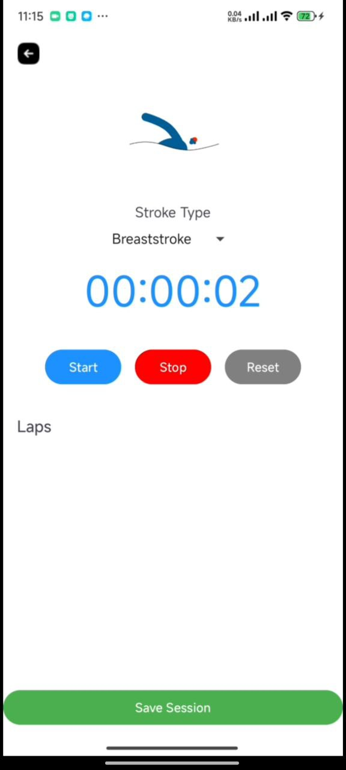
Figure 9Swimming Activity

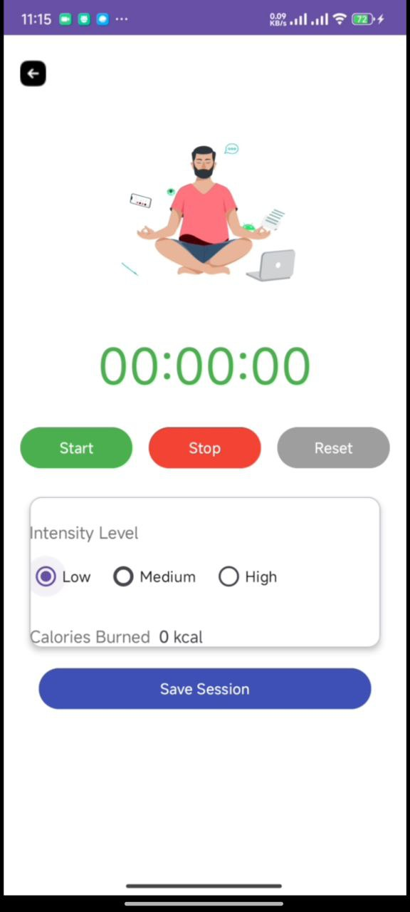
Figure 10Yoga Activity

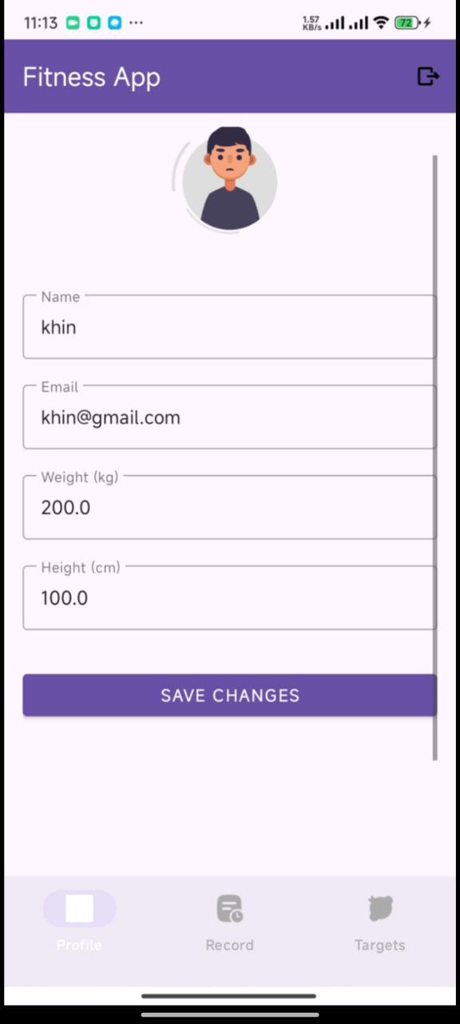
Figure 11Profile

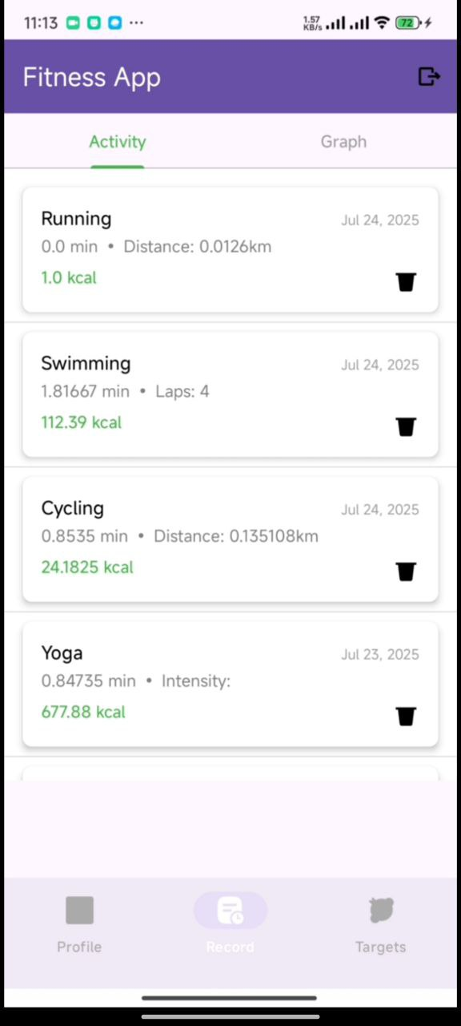
Figure 12Record Activity

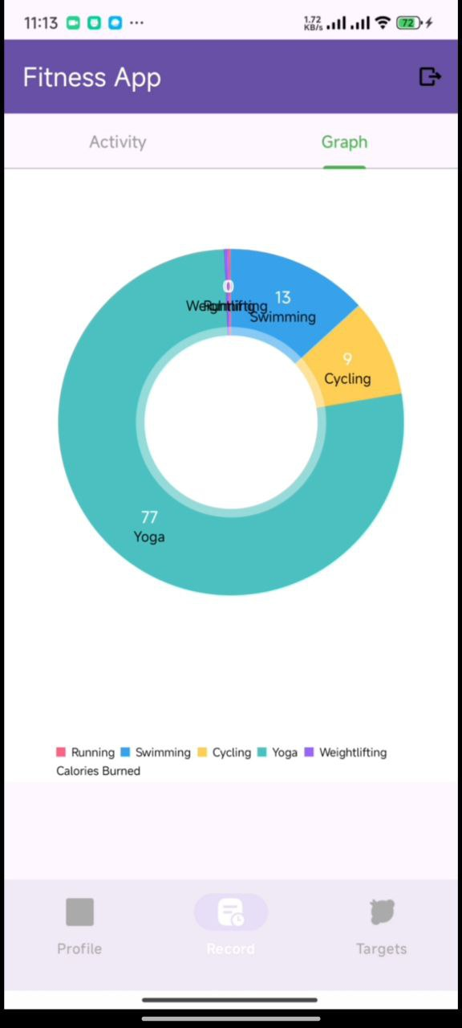
Figure 13Record Graph

Task 5

(a): Object Orientation in Kotlin and Android
Kotlin and Android application development employ Object-Oriented Programming (OOP) concepts—encapsulation, inheritance, and polymorphism—to develop modular, maintainable, and scalable code. Encapsulation hides private information (i.e., the user's health data) behind private fields and access control functions. Inheritance facilitates reusability of shared logic in parent classes like WorkoutActivity in specific activities like RunningActivity or CyclingActivity. Polymorphism supports variable behavior through shared interfaces, e.g., overriding calculateCaloriesBurned() for a particular exercise. These OOP features facilitate code reuse, testability, and ease of development in the future.

(b): Inheritance Usage in Fitness Tracking App
1. Base WorkoutActivity Class: We established a base WorkoutActivity superclass for common uses of all activities like beginning/ceasing timers, reading GPS locations, and presenting session statistics. Inherited from others like RunningActivity, CyclingActivity, and WeightliftingActivity, the base is used for taking advantage of and building upon core functions without having to memorize them.
2.Custom Adapter Util Classes: Workout history was displayed through a BaseAdapter with a generic RecyclerView. CyclingHistoryAdapter and RunningHistoryAdapter are subclass adapters with inheritance from the base class who override methods like bindView() to represent different metrics with common functionality remaining intact.
3.Hierarchical Session Model: There is a root class WorkoutSession that establishes general attributes such as duration, distance, and calorie burned. It is subclassed from classes RunningSession as well as WeightliftingSession, which add dedicated fields (pace for running, reps for strength) to allow for organized manipulation of data.
[Word Count : 231 ]

References

A Wondershare Company, E., 2024. UML Class Diagram Examples. [Online]
Available at: https://www.edrawsoft.com/example-uml-class-diagram.html
Anon., 2024. Fireart. [Online]
Available at: https://fireart.studio/blog/10-key-characteristics-of-a-successful-mobile-app-for-every-business/
[Accessed 7 july 2025].
Anon., 2025. Actualizatec. [Online]
Available at: https://actualizatec.com/en/blog/native-app/
[Accessed 25 july 2025].
Anon., 2025. headspin. [Online]
Available at: https://www.headspin.io/blog/sdlc-model-guide-for-mobile-app-development
[Accessed 25 july 2025].
Anon., 2025. Kotlin Multiplatform. [Online]
Available at: https://www.jetbrains.com/help/kotlin-multiplatform-dev/cross-platform-frameworks.html#key-takeaways
[Accessed 7 july 2025].

